Writer inventory letter
Course
Professor
Date
How I have improved as a writer
I have worked on making my sentences more concise and effective. It is my view that this move will help me to continuously improve my writing even in the future. I have taken the initiative to read books and especially books authored by poets who are experienced in the game.
Learning what is good writing
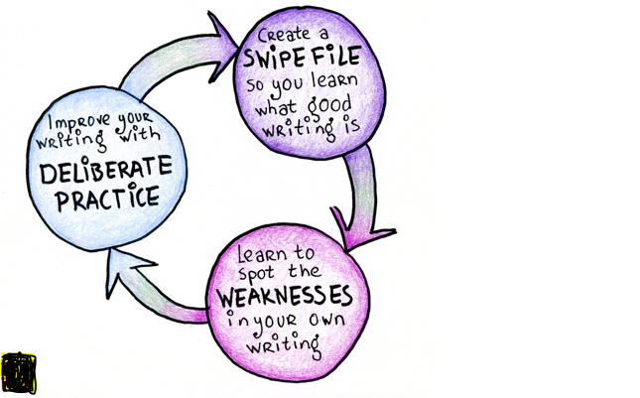
Strengths
The first item which I have taken in order to learn what is good writing is to understand where my strengths are. I have taken writing a a form of expression and this calls for writing the right words. Good writing can be challenging but once practiced, it becomes easy. I have realized I can learn good writing through my assignments and general writing of my papers which I have put a lot of efforts in. deliberate practice is essential and it has become my strength.
Weaknesses
- Poor mastery of words
- Poor communication
Things that could be improved
- Proofreading and editing
- Sentence structure

